‘Go Green on Lamma Island’ Programme Series
(2): Low Carbon Lifestyle

Field Trip Activities on Lamma Island

Name: _______________( ) | S. ____ | Date: ___________
Stop 1 Yung Shue Wan Main Street

Part 1 Rubbish – what’s the solution?
- What sustainable method is used to deal with waste in Yung Shue Wan?

- List three benefits of using the method mentioned in Question 1.

- Work in groups and walk along the main street. Find out the collection points for recyclable materials. On the map below (Figure 1), mark and label the area where they are for each of the following products with corresponding letters.
- Paper (b) Plastics (c) Metal s (d) Glass bottles
(e) Rechargeable batteries (f) Clothes (g) Small electrical appliances
Figure 1
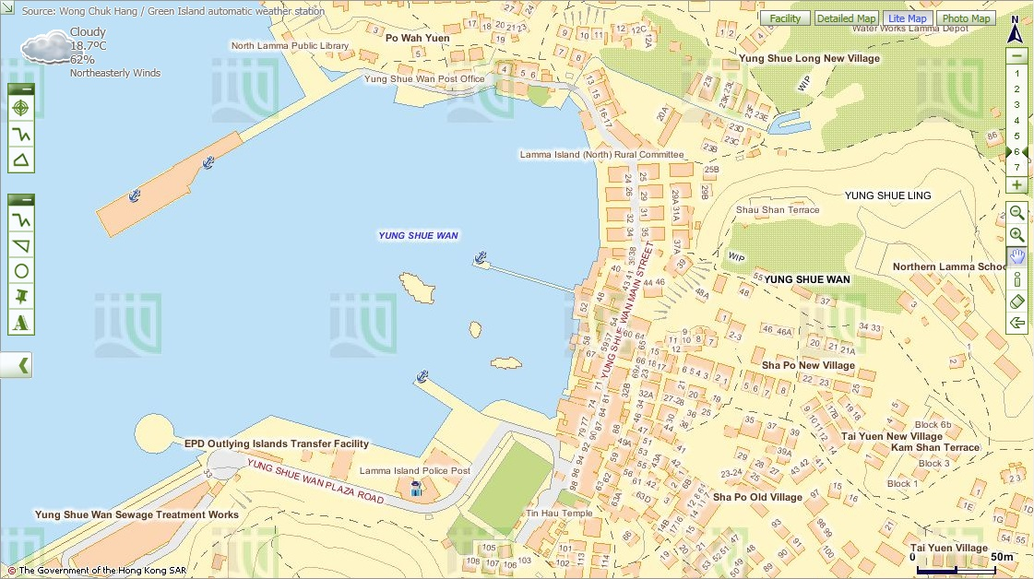
Police
Post
Map from Lands Department
- Evaluate whether the waste separation and recycling scheme is successful:
- Are all items mentioned in Question 3 collected for recycling? If not, which
item(s) is / are not collected?

- Are recycling collection points accessible?
- Are recycling collection points enough for the public? Give evidence to
support your answer.

- Suggest two ways to improve the scheme so that more people, including visitors use it more often.

Part 2 Closed loop recycling – what is it?
Visit ‘Lamma Corner’.
- Find out what three types of recyclable materials mentioned in Part I Question 3 are used for making the items.
Recyclable materials | Uses (Give at least one example)

- Figure 2 shows the closed loop recycling that is practised on Lamma Island.
Figure 2
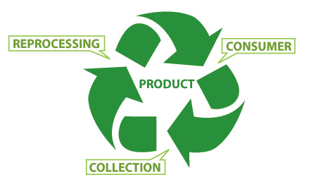
MANUFACTURING
COLLECTING

PURCHASING

The closed loop recycling involves three processes, including

- How can this closed loop recycling help combat climate change?

- As a consumer, what roles should you play in the recycling loop to help combat climate change?

- Do you think that all recyclable materials collected can enter the loop of recycling? Why?

- (a) If the recyclable materials cannot be used for recycling, where will they go?

Taking into consideration of your answers in (a) and (b), do you think
recycling is a good way to combat climate change? What else can we
do to combat climate change?
- Do you think all the recyclable materials are recycled locally in Hong Kong? Why?

- Taking into consideration of your answers in (a) and (b), do you think recycling is a good way to combat climate change? Why? What else can we do to combat climate change?

Part 3 Eco shopping
Work in groups and walk along the street.
- Go to one of the green shops and select two types of packaged food that you think they are environmentally-friendly. Complete the following table based on the information on their labels.
 | Food A | Food B
- Name of food
- Is the food homemade? If not, where is it produced? | Yes No  If no,  Hong Kong  The Mainland  Other countries | Yes No  If no,  Hong Kong  The Mainland  Other countries
- Is the food made from organic farms?
- Number of ingredients
- Do the ingredients come from plants or animals? Give two examples. | Plants Animals  Both  Examples:  _____________________  _____________________ | Plants Animals  Both  Examples:  _____________________  _____________________
- What is/are the packaging material(s)? | plastic bag  paper  others _____________ | plastic bag  paper  others: _____________

2. Which food would you like to buy in order to reduce more carbon emission? Give three reasons to support your answers.

Stop 2 A Local Farm
- Work in groups. Observe the operation of this farm and interview the farmer. Complete the following table.
Questions | Answers
- How to improve soil  quality? | using chemical fertiliser  using compost  covering soil with mulches  crop rotation  fallowing  agroforestry: trees are grown with crops  others _______________________
(b) How to avoid pest? | using chemical pesticide  using CD-ROMs  using plastic balls  growing different types of crops  crop rotation  growing companion crops  using insect trap  others _______________________
(c) How to use water resource? | constructing wells  building water tanks or ponds  covering soil with organic matter  using drip irrigation  others _______________________
- What tools are used for farming? | using simple tools, e.g. ___________  using machines, e.g. ___________
(e) What is the useful output? | crops, e.g. _____________________  animal products, e.g. ___________

- Do you think this way of operation of farm can reduce carbon emissions? Give reasons.
 | Can it help to reduce carbon emission? Put ‘’ or ‘’ | If yes, how can this help to reduce carbon emission?
- Way of improving soil quality
- Way of avoiding pest
- Way of using water resource
- Tools used for farming
- Type of output
- Would you like to buy agricultural produce grown in this type of farm for reducing climate change? Give reasons to support your answers.

Stop 3 Hung Shing Yeh Beach Tree Planting Site
- Read the information from an interpretive plate. What are the two types of trees? Give one example of each type of trees.
Type | Example

- Which type of trees is chosen for plantation at this site? Why?

- How can the planting of trees help reduce climate change?

- Apart from planting of trees, what else can we do to help reduce climate change at this site? Suggest at least two methods.

Stop 4 The Home Farm

At Lo So Shing Village, observe the activity held outside the village houses
- What activity is carried out outside the village houses?
- Can you find a large piece of farmland?
- What agricultural produce is grown from the farm?

- Do you think that the produce is for self-consumption only? Give reason to support your answer.

- How can the growing of our own food help reduce carbon emission in Hong Kong?

- Could you grow your own food at home? Why or why not?
- What else can we do for food supply to reduce climate change?

Stop 5 Mudflat

- What are the characteristics of mudflat?
- What is its relief?
- What is made up of the mudflat?
- Does the depth of water vary from time to time?
- What kinds of living organisms live in the mudflat?
Examples
Plants
Wetland Animals
- What does Mudflat provide for these living organisms?

- Do all the animals live in the water all the time?
- How will climate change affect the water level in the mudflat?

- How will the change in the water level affect the living organisms?

- What should you do to protect these living organisms in our daily life?

